ASSINGMENT 1:

Roll no : 17f-8195.

Name : Muhammad usama.

Section :B

Task 1::static working:

#include<iostream>

usingnamespace std;

void chack_static(int&x);

int main()

{

int x=0;

chack_static(x);

chack_static(x);

chack_static(x);

cout<<"value of x : "<<x<<endl;

system("pause");

return 0;

}

void chack_static(int&x)

{

staticint i=0; //static variable initialize only once.

i++;

x=i;

}

Result:

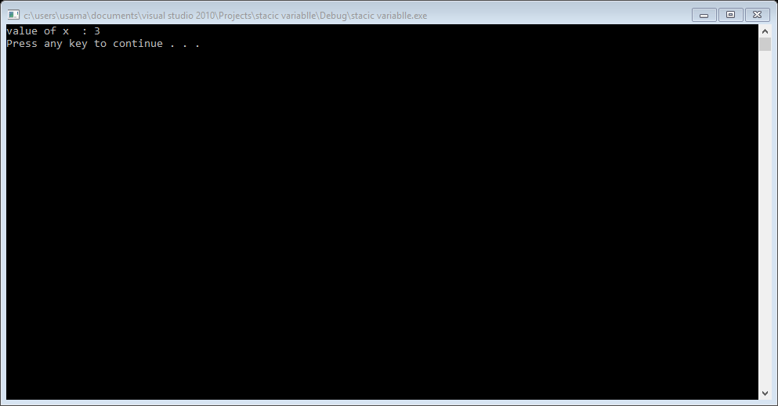

Task: 1::static workig::

#include<iostream>

usingnamespace std;

staticint x=0; //we do same process to check with x and y.

int y=0; //they behave same. because we declare both in global.

void fun(); /*if we use static in file means its scope only in

this file. and cannot be accessable in any other file */

int main()

{

x++;

y++;

cout<<"in main x : "<<x<<endl;

cout<<"in main y : "<<y<<endl;

fun();

system("pause");

return 0;

}

void fun()

{

x++; /* they show same behaviour if we declare both in global.

woring of static variable is different. if we declare in

function. as we do in above programe.*/

y++;

cout<<"in function x : "<<x<<endl;

cout<<"in function y : "<<y<<endl;

}

Result:

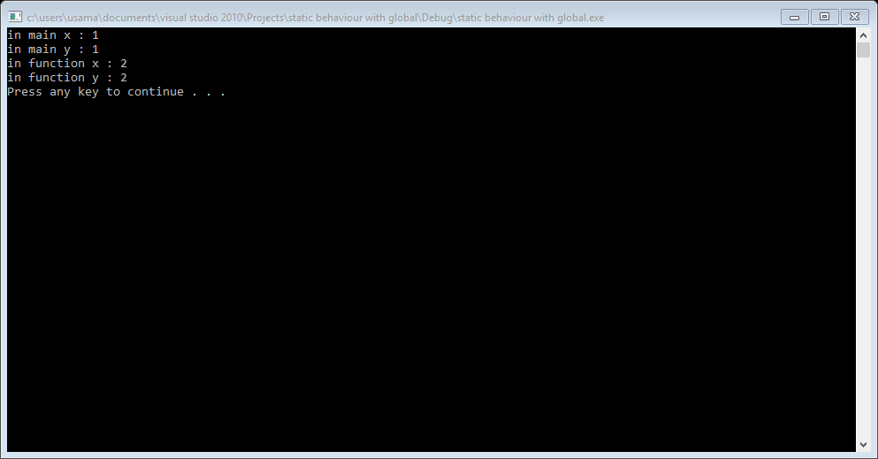

Task 2::auto working.

#include<iostream>

usingnamespace std;

int main()

{

auto a=5; /*this auto automaticaly make it integer type variable.

and auto scope is local.*/

auto x=5.322; /*this auto make automaticaly a double or float type variable.

and auto scope is local.*/

auto y=x*3; /*auto made y auto as tpe of variable that tpe of value store in y.

and auto scope is local.*/

cout<<"answer of y is : "<<y<<endl;

auto ch='a'; /*auto made ch charater variable automaticaly.

and auto scope is local.*/

auto str="my name is usama"; /*auto made str string type variable.

and auto scope is local.*/

system("pause");

return 0;

}

Result:

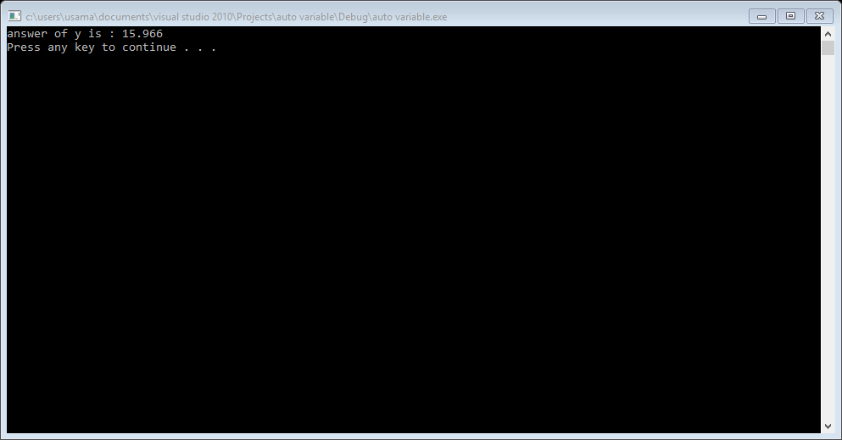

Task 3::extern working::

#include<iostream>

usingnamespace std;

void disp();

int main()

{

externint x;

cout<<x<<endl;

disp();

system("pause");

return 0;

}

int x=10; /*it must declare any where in the programe.

if extern declare in main even you declare it in the

function.if you not declare it error occure undeclare x.

and extern scope is global. It can be shared amoung multiply files */

void disp()

{

x++;

cout<<"value of x : "<<x<<endl;

}

Result:

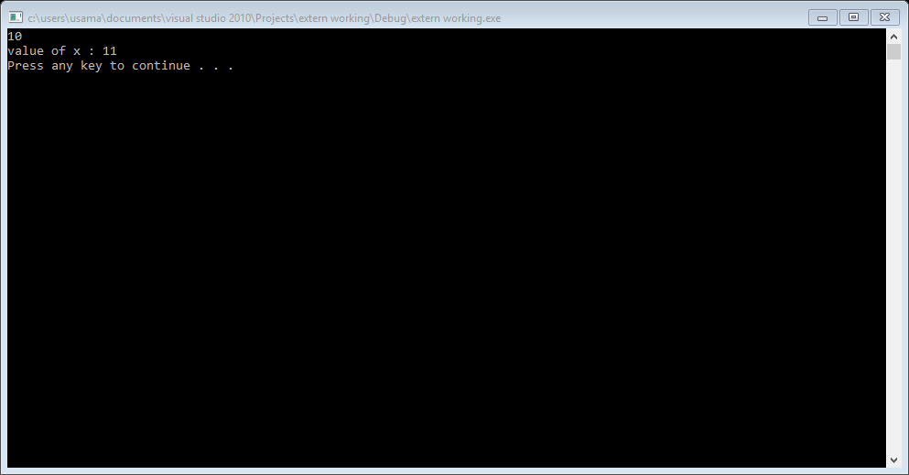

Task 4::register ::

#include<iostream>

usingnamespace std;

int main()

{

registerint x=10; //this register show that memory allocate to x in registers ma

be. register is use to define local variable

x=12;

cout<<x<<endl;

system("pause");

return 0;

}

Result:

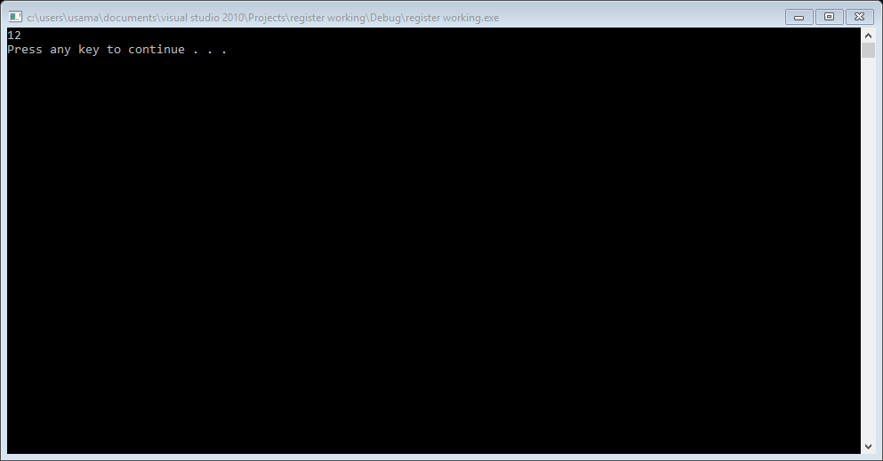

Task 5:: linear search::

#include<iostream>

usingnamespace std;

void linear_search(int list[],int size,int key);

int main()

{

int list[]={0};

int size=0,key=0;

cout<<"enetr the size of list : ";

cin>>size;

for(int i=0; i<size; i++)

{

cout<<"enter "<<i+1<<" element : ";

cin>>list[i];

}

cout<<"enter the key that you want to search : ";

cin>>key;

linear_search(list,size,key);

system("pause");

return 0;

}

void linear_search(int list[],int size,int key)

{

int *adress=0;

for(int i=0; i<size; i++)

{

if(list[i]==key)

{

cout<<"your number is found : "<<list[i]<<endl;

}

adress=&list[i];

cout<<"your key is found at this address : "<<adress<<endl;

break;

}

}

Result:

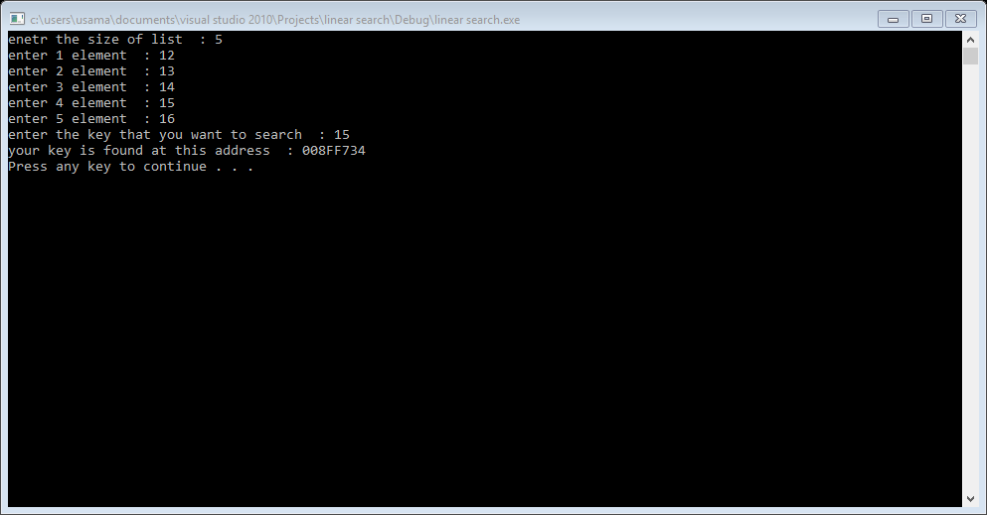

Task 6::

#include<iostream>

#include<time.h>

#include<fstream>

#include<iomanip>

#include<time.h>

usingnamespace std;

void writing_file();

void read_file();

void bubble_sort();

void selection_sort();

void writing_section_sort_file();

void writing_bubble_sort_file();

void count_random_file();

void binary_search();

void linear_search();

ifstream read;

ofstream write;

int readf[1000]={0};

int count[100000]={0};

int key=0;

int fkey=0;

int stime=0,btime=0,bsearch_time=0,linear_time=0;

char selection=0;

int main()

{

writing_file();

read_file();

count_random_file();

cout<<"what type of sorting you want \npress b for bubble sort \npress s for selection sort\npress A for both type of sorting"<<endl;

cin>>selection;

if(selection=='s'||selection=='S')

{

selection_sort();

writing_section_sort_file();

}

elseif(selection=='b'||selection=='B')

{

bubble_sort();

writing_bubble_sort_file();

}

elseif(selection=='A'||selection=='a')

{

selection_sort();

writing_section_sort_file();

bubble_sort();

writing_bubble_sort_file();

}

else

{

cout<<"you press invalid key"<<endl;

}

cout<<"press b for binary search \npress l linear search"<<endl;

cin>>selection;

if(selection=='b'||selection=='B')

{

binary_search();

}

elseif(selection=='l'||selection=='L')

{

linear_search();

}

else

{

cout<<"invalid option"<<endl;

}

if(fkey==key)

{

cout<<"your no seached that is : "<<fkey<<endl;

}

else

{

cout<<"your key not found"<<endl;

}

system("pause");

return 0;

}

void writing_file()

{

srand(time(0));

write.open("random_data.txt");

if(write.is_open())

{

for(int i=0; i<1000; i++)

{

write<<setw(7)<<rand()%1000;

}

}

else

{

cout<<"file not open"<<endl;

}

write.close();

}

void read_file()

{

read.open("random_data.txt");

if(read.is_open())

{

for(int i=0; i<1000; i++)

{

read>>readf[i];

}

}

else

{

cout<<"file not open "<<endl;

}

read.close();

}

void selection_sort()

{

int i=0,smalli=0,temp=0;

for(i=0; i<1000; i++)

{

smalli=i;

for(int j=i; j<1000; j++)

{

if(readf[j]<readf[smalli])

{

smalli=j;

}

}

temp=readf[smalli];

readf[smalli]=readf[i];

readf[i]=temp;

}

stime=time(0);

cout<<"the time required for selection sort : "<<stime<<" ms"<<endl;

}

void bubble_sort()

{

int temp=0;

int size=1000;

for(int iter=1; iter<size; iter++)

{

for(int i=0; i<size-iter; i++)

{

if(readf[i]>readf[i+1])

{

temp=readf[i+1];

readf[i+1]=readf[i];

readf[i]=temp;

}

}

}

btime=time(0);

cout<<"time taken by bubble sort : "<<btime<<endl;

}

void writing_section_sort_file()

{

write.open("selection_sort.txt");

if(write.is_open())

{

write<<"this sorting is done by selection sort"<<endl;

for(int i=0; i<1000; i++)

{

write<<setw(7)<<readf[i];

}

}

else

{

cout<<"file not open"<<endl;

}

write.close();

}

void writing_bubble_sort_file()

{

write.open("bubble_sort.txt");

if(write.is_open())

{

write<<"this sorting is done bubble sort"<<endl;

for(int i=0; i<1000; i++)

{

write<<setw(7)<<readf[i];

}

}

else

{

cout<<"file not open"<<endl;

}

write.close();

}

void count_random_file()

{

read.open("random_data.txt");

if(read.is_open())

{

int i=0;

while(!read.eof())

{

read>>count[i];

i++;

}

cout<<"total integer enter in random file : "<<i<<endl;

}

else

{

cout<<"file not open "<<endl;

}

read.close();

}

void linear_search()

{

cout<<"this searching is going to done by linear search"<<endl;

cout<<"enter key that you seach"<<endl;

cin>>key;

for(int i=0; i<1000; i++)

{

if(key==readf[i])

{

fkey=key;

break;

}

}

linear_time=time(0);

cout<<"time taken by linear search : "<<linear_time<<" ms"<<endl;

}

void binary_search()

{

cout<<"this searching is going to done by binary search method"<<endl;

int size=1000;

int fist=0,last=0,mid=0;

last=size-1;

cout<<"eneter key that yoy want to seach"<<endl;

cin>>key;

for(int i=0; i<size; i++)

{

mid=(fist+last)/2;

if(readf[mid]==key)

{

fkey=key;

}

elseif(readf[mid]<key)

{

fist=mid+1;

}

elseif(readf[mid]>key)

{

last=mid-1;

}

else

{

cout<<"invalid key"<<endl;

}

}

bsearch_time=time(0);

cout<<"time taken by binary search : "<<bsearch_time<<" ms"<<endl;

}

Result::

